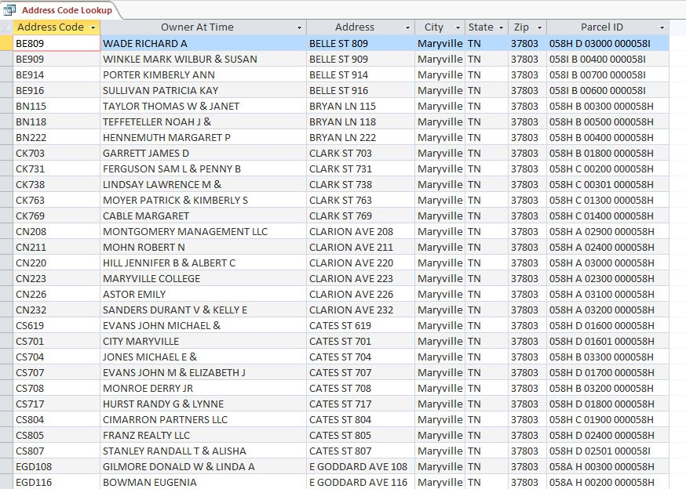

Query Name: Address Code Lookup

Created by: Maude Volk

Used by: Dropdown menu of DataSoup DB referencing data field Address Code.

Parameters: N/A

SQL Statement:

SELECT ADDRESS.AddrCode, PROPERTY_STATUS.OwnerAtTime, ADDRESS.Address, ADDRESS.City, ADDRESS.State, ADDRESS.Zip, ADDRESS.Parcel_ID

FROM ADDRESS INNER JOIN PROPERTY_STATUS ON ADDRESS.[AddrCode] = PROPERTY_STATUS.[AddrCode];

Outputs To: Dropdown menu

Purpose: To provide a user friendly way of allowing officers to select address codes when entering new members into the system.

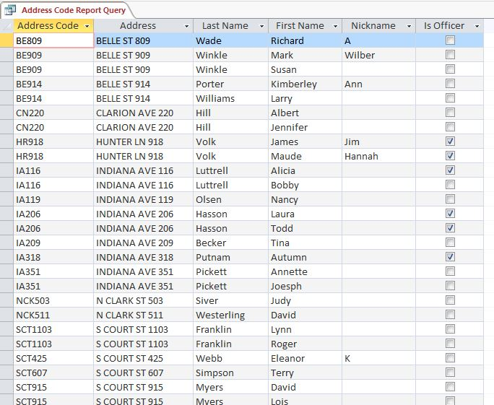

Query Name: Address Code Report Query

Created by: Calvin Scott

Used by: Officers that might desire to print out all the address codes for reference.

Parameters: N/A

SQL Statement:

SELECT ADDRESS.AddrCode, ADDRESS.Address, MEMBER.LastName, MEMBER.FirstName, MEMBER.NickName, MEMBER.Is_Officer

FROM ADDRESS RIGHT JOIN MEMBER ON ADDRESS.[AddrCode] = MEMBER.[AddrCode]

WHERE (((ADDRESS.Address) Is Not Null) AND ((MEMBER.Is_Officer)=Yes Or (MEMBER.Is_Officer)=No))

ORDER BY ADDRESS.AddrCode, ADDRESS.Address, MEMBER.LastName, MEMBER.FirstName;

Outputs To: Address Code Report

Purpose: This query provides a hard-copy reference document for member and address information associated with a given address code.

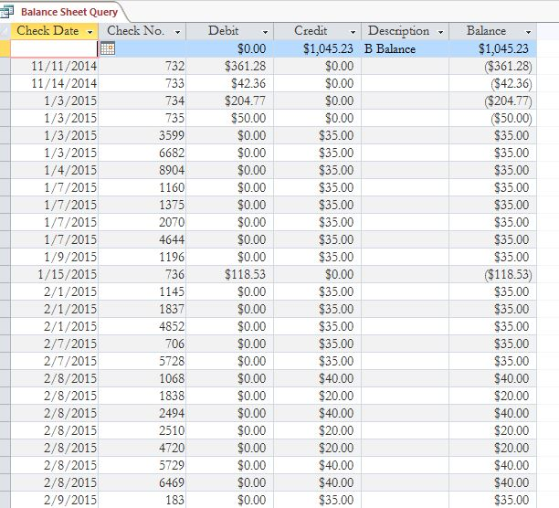

Query Name: Balance Sheet Query

Created by: Donna Walker

Used by: Treasurer

Parameters: Could easily be used to pull a periodic report once more data is added.

SQL Statement: SELECT TRANSACTION.CheckDate, TRANSACTION.CheckNum, TRANSACTION.Debit, TRANSACTION.Credit, TRANSACTION.Description, [TRANSACTION]![Credit]-[TRANSACTION]![Debit] AS Expr1

FROM [TRANSACTION]

GROUP BY TRANSACTION.CheckDate, TRANSACTION.CheckNum, TRANSACTION.Debit, TRANSACTION.Credit, TRANSACTION.Description, [TRANSACTION]![Credit]-[TRANSACTION]![Debit];

Outputs To: Balance Sheet Query

Purpose: To provide an ongoing balance of funds for the neighborhood organization.

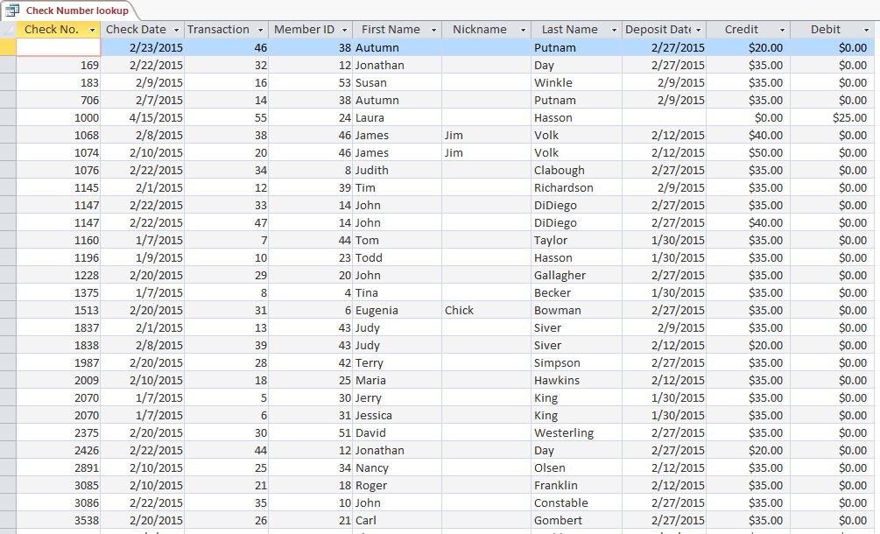

Query Name: Check Number Lookup

Created by: Calvin Scott

Used by: Treasurer or member

Parameters: N/A

SQL Statement: SELECT TRANSACTION.CheckNum, TRANSACTION.CheckDate, TRANSACTION.TransNum, TRANSACTION.MemberID, MEMBER.FirstName, MEMBER.NickName, MEMBER.LastName, TRANSACTION.DepDate, TRANSACTION.Credit, TRANSACTION.Debit

FROM MEMBER INNER JOIN [TRANSACTION] ON MEMBER.[MemberID] = TRANSACTION.[MemberID]

ORDER BY TRANSACTION.CheckNum;

Outputs To: N/A

Purpose: Provides an easy way to locate a transaction number and deposit date based on a known check number.

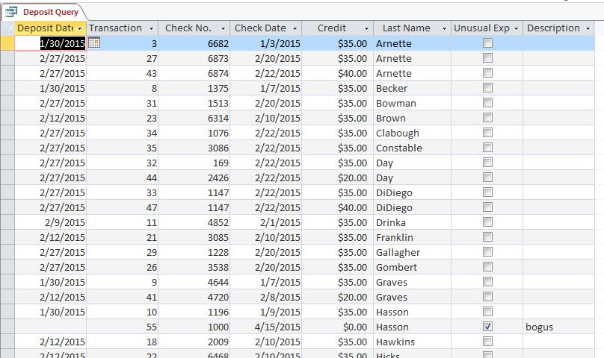

Query Name: Deposit Query

Created by: Donna Walker

Used by: Treasurer or other officers

Parameters: User defines a range of possible deposit dates to include in the query.

SQL Statement: SELECT TRANSACTION.DepDate, TRANSACTION.TransNum, TRANSACTION.CheckNum, TRANSACTION.CheckDate, TRANSACTION.Credit, MEMBER.LastName, TRANSACTION.UnusualExp, TRANSACTION.Description

FROM MEMBER INNER JOIN [TRANSACTION] ON MEMBER.[MemberID] = TRANSACTION.[MemberID]

WHERE (((TRANSACTION.DepDate)>[Start Date] And (TRANSACTION.DepDate)<[End Date]));

Outputs To: Deposit Report

Purpose: To track credit transactions by deposit date.

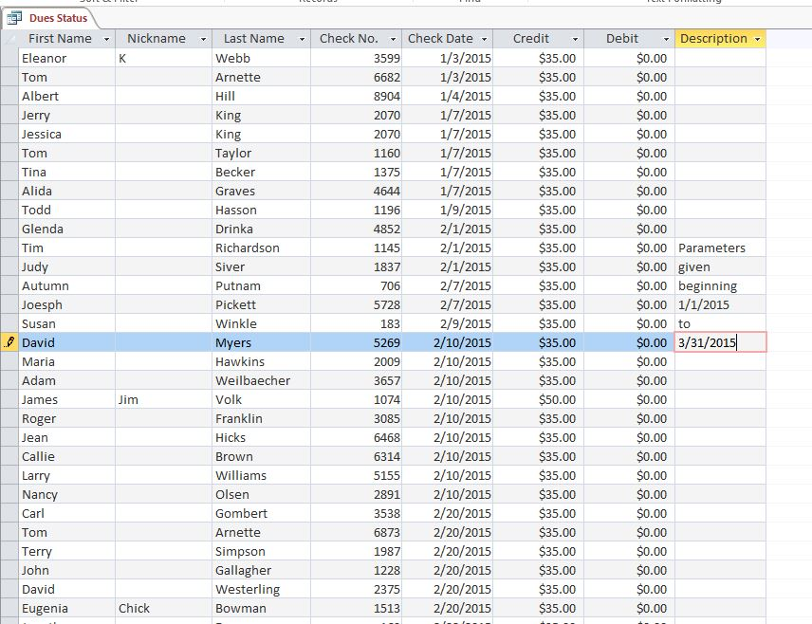

Query Name: Dues Status

Created by: Kyle Tuczynski

Used by: Membership Chair and Treasurer

Parameters: User defines start and end date based on check date.

SQL Statement: SELECT TRANSACTION.DepDate, TRANSACTION.TransNum, TRANSACTION.CheckNum, TRANSACTION.CheckDate, TRANSACTION.Credit, MEMBER.LastName, TRANSACTION.UnusualExp, TRANSACTION.Description

FROM MEMBER INNER JOIN [TRANSACTION] ON MEMBER.[MemberID] = TRANSACTION.[MemberID]

WHERE (((TRANSACTION.DepDate)>[Start Date] And (TRANSACTION.DepDate)<[End Date]));

Outputs To: N/A

Purpose: To assist the Membership Chair and Treasurer with tracking annual dues payments.

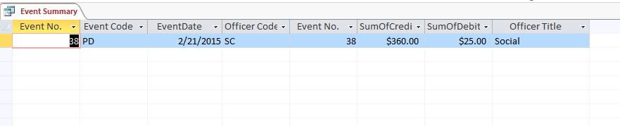

Query Name: Event Summary

Created by: Maude Volk

Used by: Social Chair and Treasurer

Parameters: N/A

SQL Statement: SELECT EVENT.EventNum, EVENT.EventCode, EVENT.EventDate, TRANSACTION.OfficerCode, TRANSACTION.EventNum, Sum(TRANSACTION.Credit) AS SumOfCredit, Sum(TRANSACTION.Debit) AS SumOfDebit, OFFICER.OfficerTitle

FROM OFFICER INNER JOIN (EVENT INNER JOIN [TRANSACTION] ON EVENT.EventNum = TRANSACTION.EventNum) ON OFFICER.OfficerCode = TRANSACTION.OfficerCode

GROUP BY EVENT.EventNum, EVENT.EventCode, EVENT.EventDate, TRANSACTION.OfficerCode, TRANSACTION.EventNum, OFFICER.OfficerTitle, OFFICER.OfficerCode

ORDER BY EVENT.EventDate;

Outputs To: Event Summary Report

Purpose: To summarize Credits and Debits associated with a given event. The report is sorted by Event Date.

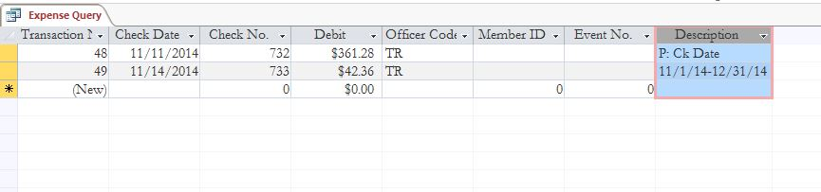

Query Name: Expense Query

Created by: Donna Walker

Used by: Treasurer

Parameters: These are user defined based on Check Date. In the above example, the Check Date domain selected is provided in the Description field.

SQL Statement: SELECT TRANSACTION.TransNum, TRANSACTION.CheckDate, TRANSACTION.CheckNum, TRANSACTION.Debit, TRANSACTION.OfficerCode, TRANSACTION.MemberID, TRANSACTION.EventNum, TRANSACTION.Description

FROM [TRANSACTION]

WHERE (((TRANSACTION.CheckDate)>[Start Date] And (TRANSACTION.CheckDate)<[End Date]) AND ((TRANSACTION.Debit)>0));

Outputs To: Expense Report

Purpose: To track association expenses for a user defined time period. This report can generate monthly, annual and period expense reports.

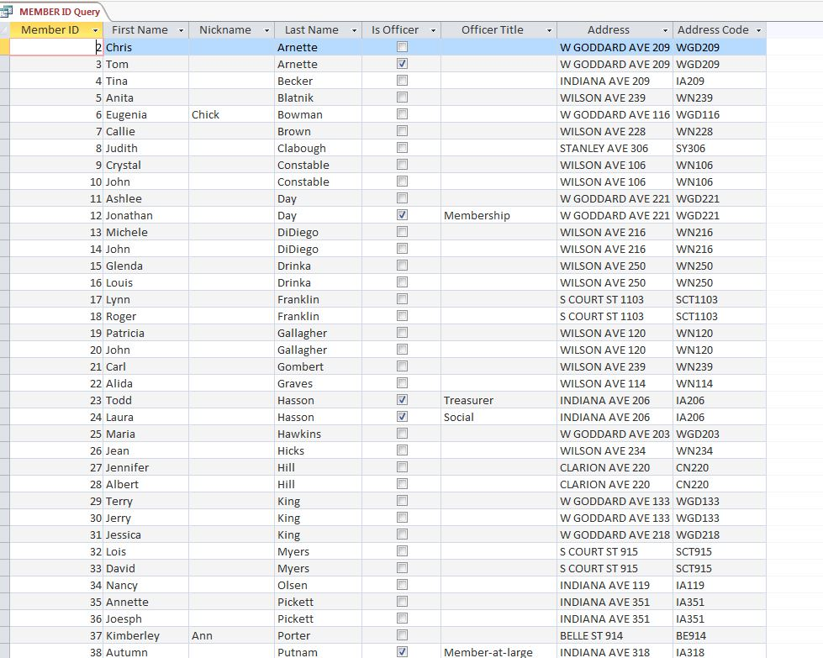

Query Name: Member ID Query

Created by: Calvin Scott

Used by: Association Officers

Parameters: N/A

SQL Statement: SELECT MEMBER.MemberID, MEMBER.FirstName, MEMBER.NickName, MEMBER.LastName, MEMBER.Is_Officer, OFFICER.OfficerTitle, ADDRESS.Address, ADDRESS.AddrCode

FROM (ADDRESS INNER JOIN MEMBER ON ADDRESS.[AddrCode] = MEMBER.[AddrCode]) LEFT JOIN OFFICER ON MEMBER.[MemberID] = OFFICER.[MemberID]

ORDER BY MEMBER.MemberID;

Outputs To: Member ID Report

Purpose: To provide member’s name, address, address code, and officer status given a known Member ID number.

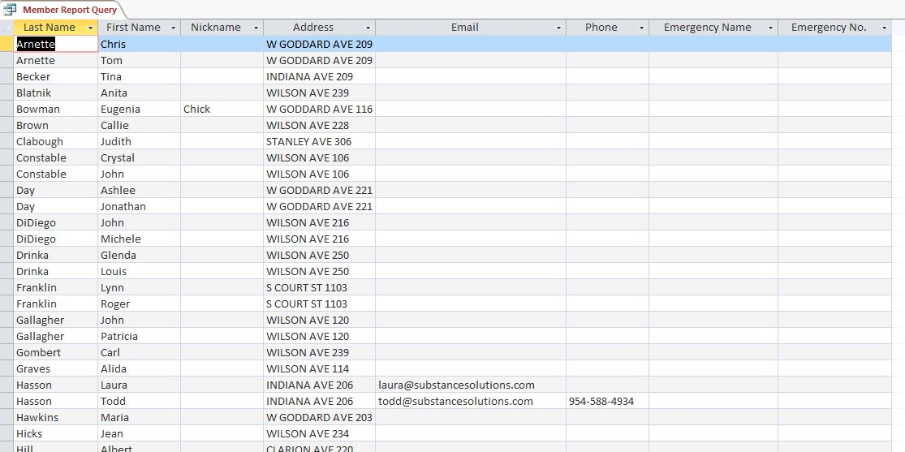

Query Name: Member Report Query

Created by: Calvin Scott

Used by: The association membership and officers

Parameters: N/A

SQL Statement: SELECT MEMBER.LastName, MEMBER.FirstName, MEMBER.NickName, ADDRESS.Address, MEMBER.Email, MEMBER.Phone, MEMBER.EmergencyName, MEMBER.EmergencyNumber

FROM (ADDRESS INNER JOIN MEMBER ON ADDRESS.[AddrCode] = MEMBER.[AddrCode]) LEFT JOIN OFFICER ON MEMBER.[MemberID] = OFFICER.[MemberID]

ORDER BY MEMBER.LastName, MEMBER.FirstName;

Outputs To: Membership List

Purpose: As a contact list to facilitate better communication amongst association members. This report provides each member’s name, address, phone, email and emergency contact information.

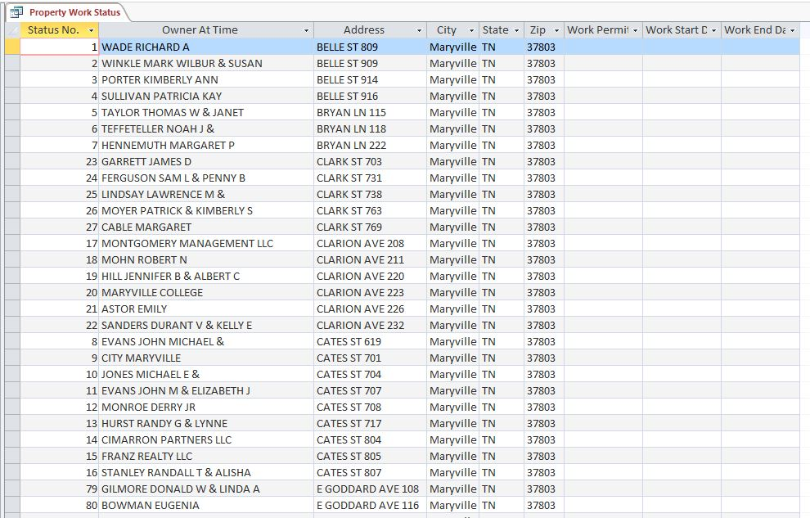

Query Name: Property Work Status

Created by: Kyle Tuczynski

Used by: Officers

Parameters: N/A

SQL Statement: SELECT PROPERTY_STATUS.StatusNum, PROPERTY_STATUS.OwnerAtTime, ADDRESS.Address, ADDRESS.City, ADDRESS.State, ADDRESS.Zip, PROPERTY_STATUS.WorkPermit, PROPERTY_STATUS.WkStDate, PROPERTY_STATUS.WkEndDate

FROM ADDRESS INNER JOIN PROPERTY_STATUS ON ADDRESS.[AddrCode] = PROPERTY_STATUS.[AddrCode];

Outputs To: N/A

Purpose: Provides officers a way to look up the ownership status and work permit status of houses within the historical district.